INTRODUCTION

1.1 Introduction
Managing a household efficiently has become increasingly challenging due to rising living costs, food wastage, inefficient inventory management, and the lack of intelligent decision-support systems. Most families rely on manual methods such as paper notes, spreadsheets, or separate mobile applications to track expenses, groceries, and household consumption. These fragmented approaches often lead to poor financial decisions, unnecessary purchases, and increased food waste.
With recent advancements in Artificial Intelligence, Large Language Models (LLMs), and Agentic AI systems, it is now possible to create intelligent assistants capable of analyzing household data, understanding user behavior, and autonomously providing recommendations. HomeOS is proposed as an AI-powered household economic intelligence platform that integrates inventory management, receipt analysis, meal planning, waste management, and expenditure tracking into a single intelligent ecosystem.
The system utilizes Agentic AI, Retrieval-Augmented Generation (RAG), vector databases, and structured databases to continuously monitor household activities and provide personalized recommendations that help families save money, reduce waste, and improve resource utilization.

1.2 Problem Statement
Modern households face several challenges in managing their daily resources and expenses. Food items are often forgotten until they expire, resulting in significant waste. Grocery purchasing decisions are frequently made without considering existing inventory levels, leading to duplicate purchases and unnecessary spending.
Additionally, households lack a centralized system capable of connecting food inventory, consumption behavior, receipts, and waste records to generate meaningful insights. Existing applications typically focus on a single functionality, such as expense tracking or inventory management, without providing intelligent recommendations based on combined household data.
As a result, families experience:
- Increased food waste.
- Poor inventory visibility.
- Unnecessary grocery expenses.
- Lack of intelligent meal planning.
- Inefficient household resource management.
- Limited awareness of spending patterns.
Therefore, there is a need for an intelligent household management platform capable of autonomously analyzing household data and generating actionable recommendations.

1.3 Aim
The aim of this project is to develop an AI-powered autonomous household economic intelligence platform that assists families in managing household resources efficiently by integrating inventory management, expense tracking, waste analysis, and intelligent meal planning into a unified system.

1.4 Objectives
The primary objectives of HomeOS are:

General Objective
To create an intelligent household management platform that optimizes household spending, reduces food waste, and improves resource utilization through AI-driven decision-making.

Specific Objectives
- Develop a centralized household inventory management system.
- Automatically extract and store information from grocery receipts.
- Monitor food consumption and waste patterns.
- Generate daily meal plans based on available inventory.
- Recommend recipes using Retrieval-Augmented Generation (RAG).
- Provide spending insights and economic recommendations.
- Reduce food wastage through predictive consumption analysis.
- Deliver real-time household intelligence through Agentic AI.

1.5 Proposed Solution
HomeOS is proposed as an autonomous AI-driven platform designed to function as a digital operating system for household economic management. The system combines structured household data with AI-powered reasoning to support better decision-making.
The platform collects information from multiple sources including household inventory records, grocery receipts, waste tracking records, and expenditure data. Receipt information is processed and stored in a vector database to enable semantic search and recipe retrieval, while operational household data is stored in a relational SQL database.
An intelligent AI agent continuously analyzes household conditions and performs tasks such as:
- Monitoring inventory levels.
- Detecting items approaching expiration.
- Generating daily meal plans.
- Recommending recipes based on available ingredients.
- Tracking household waste.
- Providing spending optimization suggestions.
- Generating household economic insights.
Through these capabilities, HomeOS transforms traditional household management into a data-driven, intelligent, and proactive system that helps families save money, reduce waste, and improve their overall quality of life.

PROPOSED SOLUTION

2.1 Introduction
HomeOS is an intelligent household management platform that integrates Artificial Intelligence, Agentic AI, Retrieval-Augmented Generation (RAG), inventory management, and expenditure analysis into a single ecosystem. The platform serves as an autonomous assistant capable of monitoring household resources, generating recommendations, and assisting users in making informed economic decisions.
The system operates by collecting household data, analyzing user behavior, and generating personalized recommendations through an intelligent AI agent.

2.2 Front-End Technologies
The frontend of HomeOS provides an interactive user interface that enables users to manage household resources efficiently.

Technologies Used
- React.js
- HTML5
- CSS3
- JavaScript
- Tailwind CSS

Front-End Responsibilities
- Dashboard visualization.
- Inventory management interface.
- Receipt upload interface.
- Meal planning display.
- Waste tracking dashboard.
- Expense monitoring dashboard.
- AI recommendation interface.

2.3 Back-End Technologies

Technologies Used
- Python
- FastAPI
- LangGraph
- Gemini API
- Pydantic
- Uvicorn
- Groq API

Back-End Responsibilities
- Data processing.
- AI agent orchestration.
- Recipe retrieval.
- Meal plan generation.
- Waste analysis.
- Inventory monitoring.
- User authentication.
- API management.

2.4 Database Technologies

SQL Database
Stored Data:
- User information.
- Inventory records.
- Waste records.
- Meal plans.
- Spending records.
- Consumption history.

Vector Database
Stored Data:
- Recipe documents.
- Receipt embeddings.
- Food knowledge base.
- Cooking instructions.

2.5 AI Technologies
The HomeOS platform utilizes several Artificial Intelligence technologies to provide intelligent decision-making, automation, and personalized household recommendations.

Large Language Models (LLMs)
Large Language Models are used to understand user requests, analyze household data, generate recommendations, and produce human-like responses. The system leverages advanced AI models such as Google Gemini to perform reasoning and decision-making tasks.

Agentic AI
Agentic AI serves as the core intelligence layer of the system. Unlike traditional AI systems that simply respond to commands, the AI agent can autonomously analyze inventory, waste records, spending patterns, and available recipes to generate daily meal plans and household recommendations.

Retrieval-Augmented Generation (RAG)
RAG combines information retrieval with generative AI. The system retrieves relevant recipes and food-related knowledge from the vector database and supplies this information to the language model, enabling more accurate and context-aware responses.

Vector Embeddings
Vector embedding technology converts recipes, receipts, and food-related documents into numerical representations that capture semantic meaning. These embeddings enable efficient similarity searches and intelligent information retrieval.

Natural Language Processing (NLP)
Natural Language Processing techniques are used to understand user queries, interpret receipt information, process textual data, and facilitate natural interaction between users and the AI system.

Optical Character Recognition (OCR)
OCR technology is used to extract text and product information from uploaded grocery receipts. This allows the system to automatically identify purchased items and update household records.

2.6 System Process
The overall system process consists of the following stages:

Step 1: Data Collection
Users upload:
- Grocery receipts.
- Inventory information.
- Waste records.

Step 2: Data Storage
Data is stored in:
- MySQL Database (structured data)
- ChromaDB (recipe and receipt embeddings)

Step 3: Data Analysis
The AI Agent analyzes:
- Available ingredients.
- Consumption patterns.
- Waste records.
- Spending history.

Step 4: Knowledge Retrieval
The RAG module retrieves:
- Relevant recipes.
- Cooking instructions.
- Ingredient alternatives.

Step 5: Decision Generation
The AI Agent generates:
- Daily breakfast plan.
- Daily lunch plan.
- Daily dinner plan.
- Shopping suggestions.
- Waste reduction strategies.

SYSTEM ANALYSIS AND DESIGN

System analysis and design is a critical phase in software development that focuses on identifying user requirements, defining system functionalities, and designing solutions that effectively address the identified problems. This chapter presents the analysis and design of the HomeOS platform, including the functional requirements, non-functional requirements, system architecture, database design, and process workflows.
The analysis phase was conducted to understand the needs of modern households and identify the features required to improve household resource management. Based on these requirements, a comprehensive system design was developed to ensure efficient operation, scalability, usability, and maintainability of the proposed solution.
The HomeOS platform integrates inventory management, receipt processing, waste monitoring, meal planning, and AI-powered decision support into a unified system. The design focuses on providing an intelligent and user-friendly environment that assists households in optimizing resource utilization, reducing food waste, and improving economic decision-making.

4.2 Functional Requirements Analysis
Functional requirements describe the specific services and operations that the system must perform.

User Registration and Authentication
The system shall allow users to create accounts, log in securely, and manage their profiles.

Inventory Management
The system shall allow users to add, update, view, and remove inventory items stored within the household.

Receipt Upload and Processing
The system shall allow users to upload grocery receipts and automatically extract product information using OCR technology.
- Food Waste Tracking
The system shall allow users to record discarded food items and maintain waste statistics.

Daily Meal Plan Generation
The system shall generate daily meal plans consisting of breakfast, lunch, and dinner recommendations based on available inventory.

Recipe Recommendation
The system shall retrieve suitable recipes from the knowledge base using Retrieval-Augmented Generation (RAG).

Spending Analysis
The system shall monitor household spending and generate expenditure reports.

AI Recommendation Generation
The system shall provide intelligent recommendations for reducing food waste and optimizing grocery purchases.

Dashboard Visualization
The system shall provide visual summaries of inventory levels, waste trends, and household spending.

Search and Retrieval
The system shall enable users to search inventory items, recipes, and historical records.

4.3 Non-Functional Requirements Analysis
Non-functional requirements define the quality attributes and operational characteristics of the system.

Performance
The system shall generate recommendations and meal plans within an acceptable response time of less than 10 seconds under normal operating conditions.

Reliability
The system shall provide consistent and accurate operation with minimal system failures and data loss.

Scalability
The system shall support future expansion, including additional AI modules, users, and household data without significant performance degradation.

Security
The system shall protect user information through authentication, authorization, and secure data storage mechanisms.

Usability
The system shall provide an intuitive and user-friendly interface that can be easily used by individuals with minimal technical knowledge.

Maintainability
The system architecture shall support easy maintenance, updates, and feature enhancements.

Diagrams

4.1 State Diagram

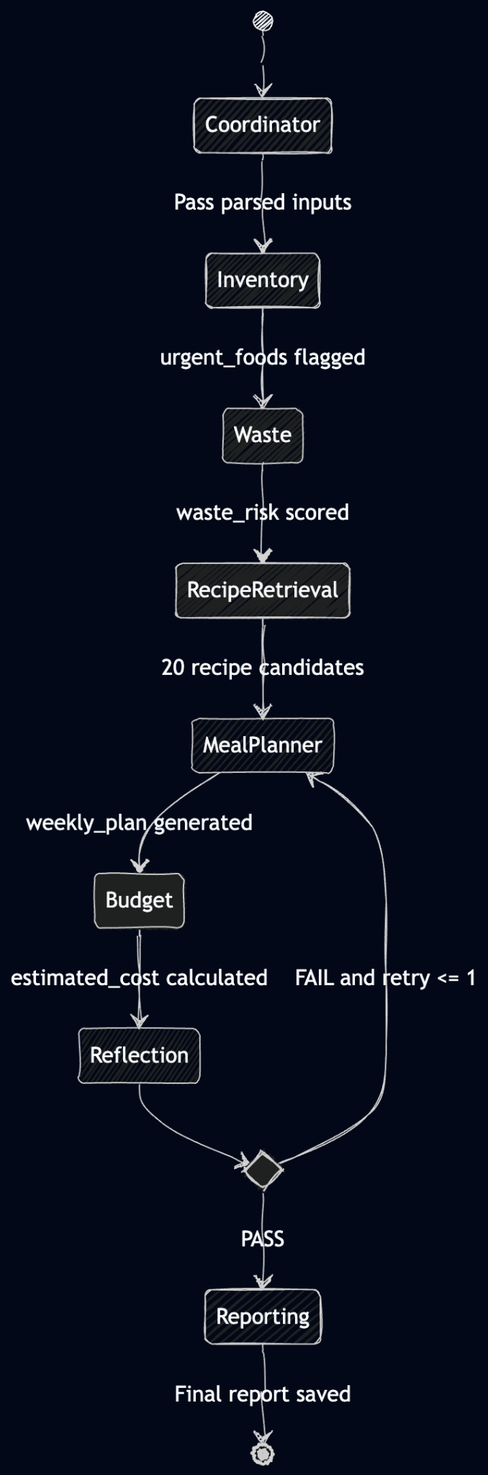

4.2 Use Case Diagram

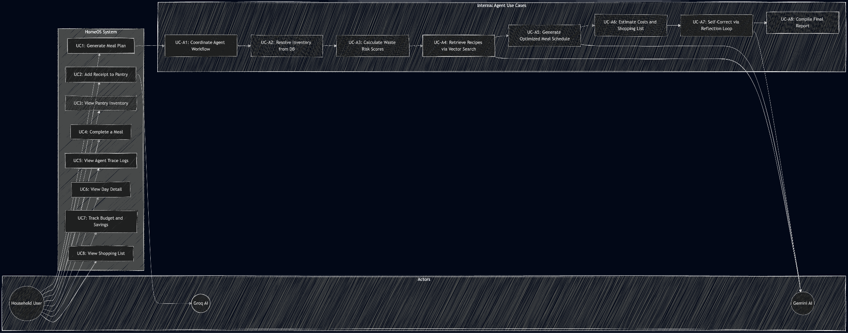

4.3 ER Diagram
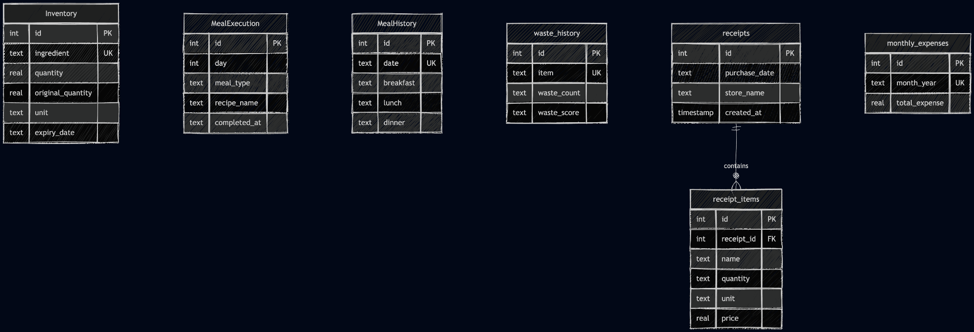

4.4 Sequence Diagram

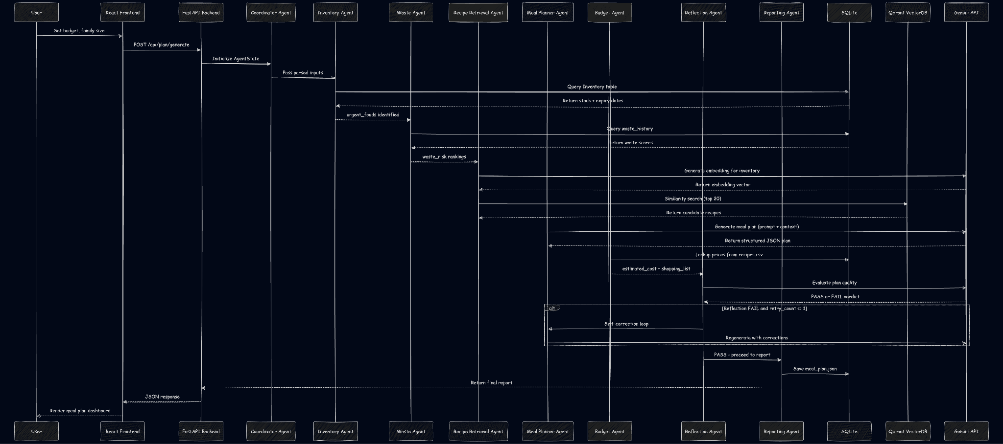

4.5 DFD Diagram

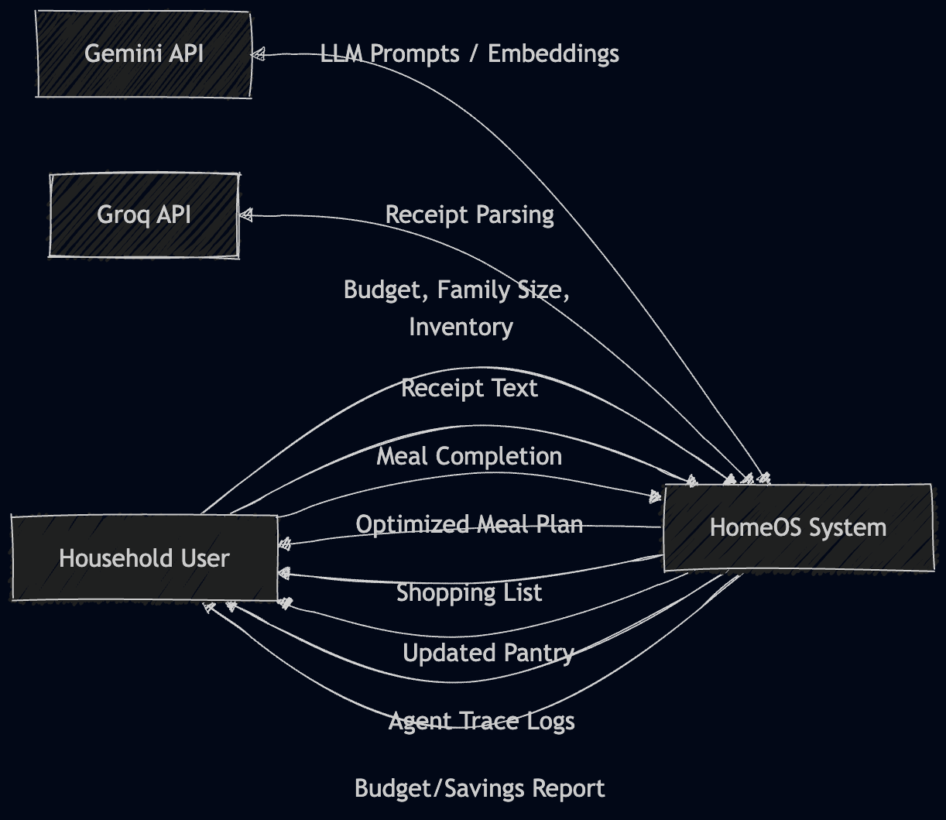

4.6 Agent Workflow

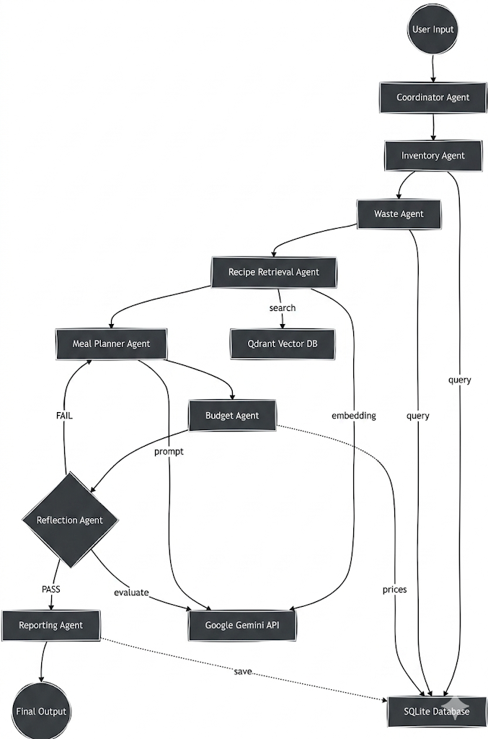

4.7 Frontend

